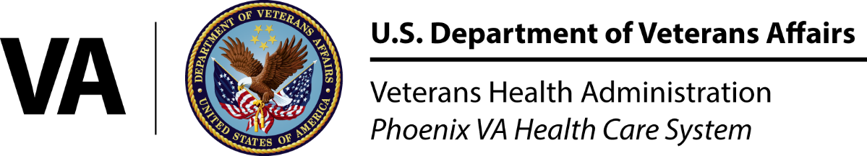

# Benefits & Qualifications

Program Director

**Jessica Hopper, PharmD, BCPS, BCPP**

## Jessica.Hopper@va.gov

Program Coordinator

**Taylor Nichols, PharmD, BCPP**

Taylor.Nichols@va.gov

## PGY2 Psychiatric Pharmacy

## NMS Code: 699466

The PGY2 Psychiatric Pharmacy program is designed to prepare pharmacy specialists for a variety of mental health settings. Learning experiences may include direct patient care in inpatient mental health, outpatient mental health, substance abuse, pain management, neurology and consult services.

Mental health pharmacists interact with interdisciplinary teams that include psychiatrists, psychologists, social workers, nurses, and medical providers. Residents will have the opportunity to grow their practice with the support of the team and preceptors.

Additional skills will be developed in research, formulary management, medication safety, medication use evaluation, and drug distribution.

Please visit the PHORCAS portal or our Web site for information about the required application and recommendation materials:

*http://www.ashp.org/phorcas*

http://www.phoenix.va.gov/careers/ *Pharmacy_Residencies.asp*

At the Phoenix VA Health Care System, pharmacy residents enjoy being fully integrated members of multidisciplinary teams. Additional residency benefits include:

* 8-10 paid federal holidays
* Paid sick leave
* 13 vacation days
* Access to federal benefits
* Travel support for national conference
* Time in federal service for benefits

Qualifications for the program include:

* United Stated citizenship
* Doctor of Pharmacy degree from an American Council of Pharmaceutical Education accredited school of pharmacy
* Pharmacist licensure in any of the United States
* National Matching Service registration

Phoenix VA Health Care System

Pharmacy Residency Training

650 E. Indian School Rd (119)   
Phoenix, AZ 85012-1892

(602)277-5551  
www.phoenix.va.gov

Phoenix VA Healthcare System

Additional integrated activities for professional growth include oral presentations, committee assignments, quality improvement project, smoking cessation classes, journal clubs, leadership seminars, and completion of a drug use evaluation and monograph.

Residents may develop individual interests in a number of elective rotations including oncology, medical/surgical specialty, emergency medicine, critical care, and infectious diseases. The program is highly flexible and allows individual advancement based on personal motivation and ability. Teaching and precepting opportunities are also available at the resident’s interest.

The PGY1 Pharmacy Practice residency program is designed to prepare pharmacists with the pharmacotherapy skills to provide comprehensive medication management services in a variety of acute and ambulatory patient care settings. A comprehensive, hands-on, clinically focused experience is achieved through a variety of practice settings. Required rotational experiences include:

* General Medicine
* Primary Care
* Geriatrics
* Mental Health
* Administration
* Anticoagulation

Program Director

**Gordana Milosevic, PharmD**

Gordana.Milosevic@va.gov

Program Coordinator

**Johanna Peragine, PharmD, MBA**

Johanna.Peragine@va.gov

PGY1 Pharmacy Practice Residency

NMS Code: 145513

The Phoenix VA Health Care System (PVAHCS) is an integrated Veteran’s Affairs health care system consisting of over 230 inpatient beds and 9 community based outpatient clinics serving over 100,000 Veterans annually.

A diverse range of rotation opportunities, interdisciplinary care teams, education oriented practice, and hands-on learning is our investment in your pharmacy training.

A growing team of more than 60 clinical pharmacists at the Phoenix VA Health Care System provides direct patient care in the areas of primary care, acute care, mental health, medical/surgical specialty, pain, emergency medicine, infectious diseases, critical care, anticoagulation, and geriatrics.

PVAHCS has academic affiliations with the University of Arizona as well as Midwestern University – Glendale. Moreover, the Pharmacy Service line also trains pharmacy students from other schools throughout the country.

# Phoenix VA Residency Program Overview